Project Report Template

1 INTRODUCTION

1.1 Overview

* The urban interior style merges industrial with contemporary design , creating a modern, bohemian look.
* The central theme that all the design elements are focused upon.

1.2 Purpose

\* Our goal is to help people overcome adversity, heal their aura, and improve their overall quality of life

\* The urban aura was organically created to radiate high, positive frequencies and encourage conscious, healthier decisions in the community.

2 Problem Definition & Design Thinking

2.1 Empathy map

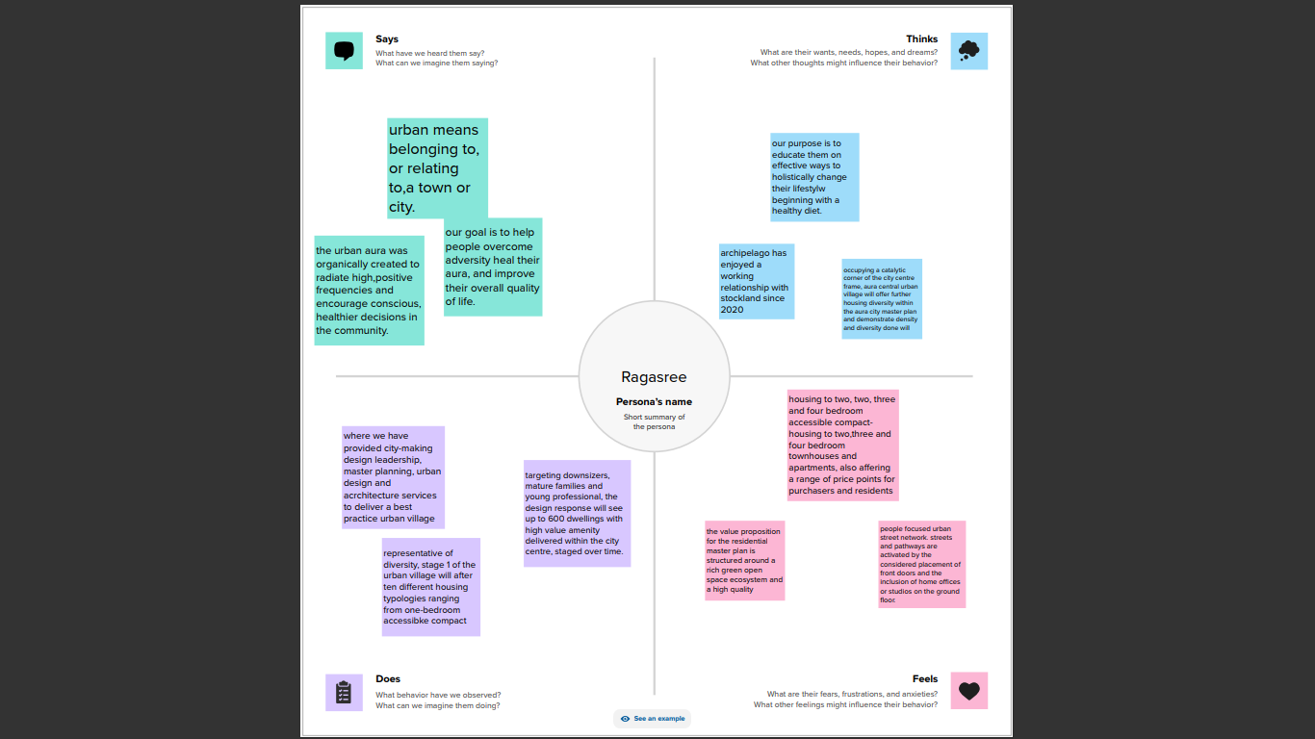

2.2 Ideation & Brainstorming map

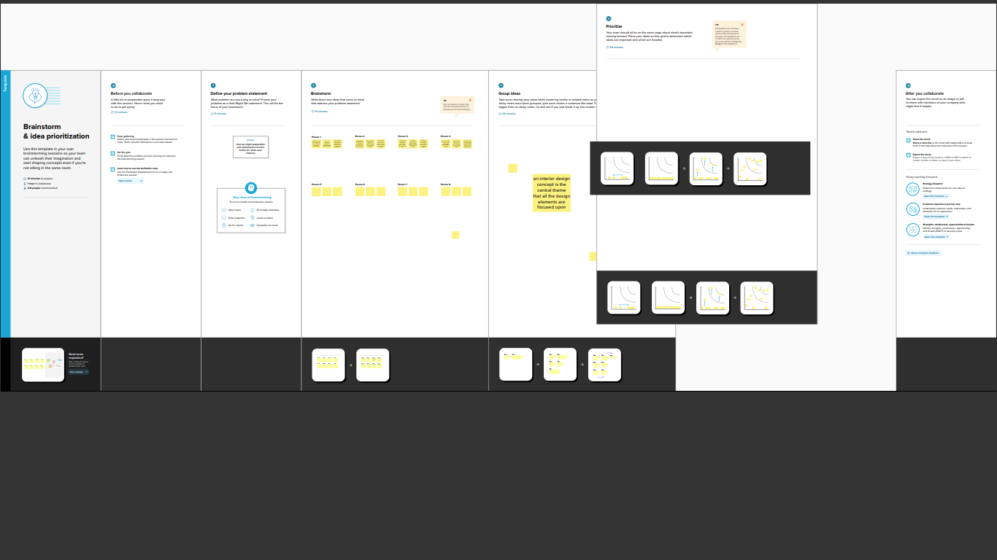

3 Result

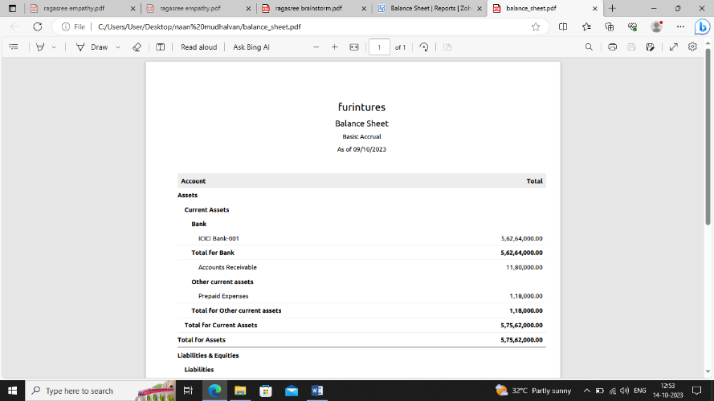

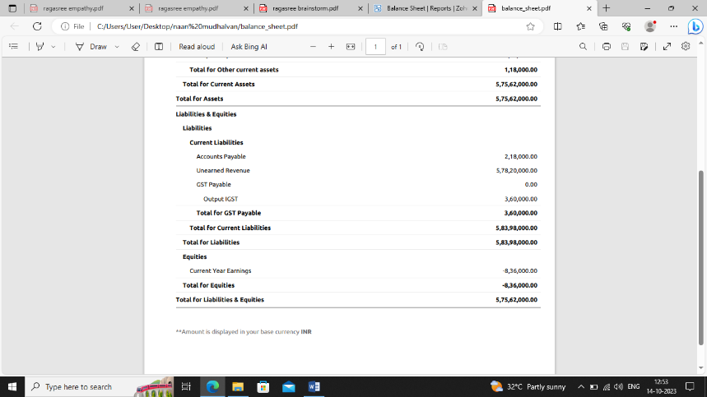

4 Advantages & disadvantages

ADVANTAGES

* I am writing a review of this after using almost 6 months.
* Due to the lockdown period, my running was very less.

DISADVANTAGES

* Low mileage as shown in the catalog only 11 – 12 km per litr.
* The city and 14-15 km on the highway as compared to quoted.

5 Applications

* Health insurance. 98% report available.54 total response.
* Life insurance.50% report available. 2 total response.

6 Conclusion

Thus the above program has been successfully excuited.

7 Future Scope

* Zoho plans to embrace transnational localism, adapting its product and services to meet the specific needs of local markets.

8 Appendix

A. Source Code

https://github.com/Rithikaeswari/1AF4664095AD21482A3449A